

**Machine Learning Internship**

Sanjay Marreddi

*Task: Report on Source Code.*

**Abstract:** I downloaded all the given data sets and Source Code provided. I went through each and every part of the code and made few changes in the code file as per my requirement. I ran the model on the Google Colab and noted the Coding structure and Limitations of the model.

**Coding Structure:**

* Import the required modules.
* Mount the drive to access the data (fer2013.csv file) present in google drive.
* Split the data into Training and Test sets based on the labels given.
* Perform Data Preprocessing steps like One hot encoding, Normalizing the data, Reshaping the data
* Create the model by adding Convolutional, Pooling, Dropout layers followed by a Flatten layer and Fully connected Dense Layers
* Compile the model and fit the model.
* Save the Model into a file of json format and Model Weights into a file of h5 format.

**Limitations:**

* I observed that the time taken for training the model that is including both Compiling and Fitting is quite large. For example, training the model for just 3 epochs takes around 25 minutes.
* Also, the Model was able to classify only certain emotions with high Accuracy like: Happy, Neutral, Sad as they have high proportion in the Training Data set as shown below which in turn resulted in ability of the Model to detect those features which corresponds to above mentioned emotions with a better accuracy.

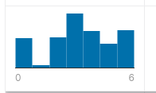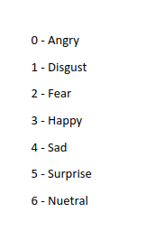

0 1 2 3 4 5 6